**DYNAMIC ALLOCATION MEMORY**

Lab Exercise # 6

Submitted by:**Sumalinog, Ethan Chav Isaac P.**

Submitted to:**Mr. Nasvin Del Rosario**

**Challenge:**

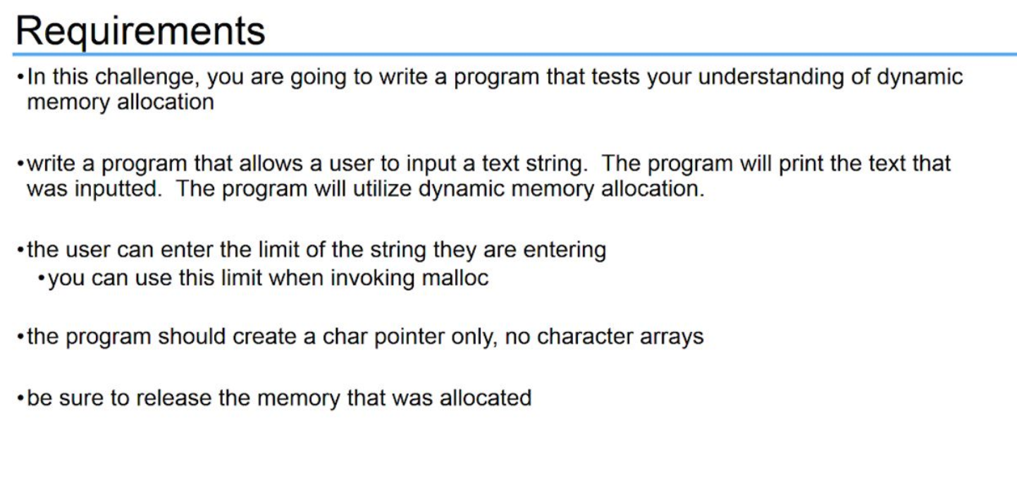

**Solution:**

I start off by declaring an integer variable *limit* that gives the ‘number of elements’ it gives to an ‘array’ to the character point *string*. After using *scanf* for the limit, I allocated memory for the pointer *string* with the limit. I created an ‘array’ in the heap with the number of elements from the limit I created, multiplied by size of the memory for characters. After using *scanf* to the address of string of the string the user type, we get the string that the user inputted. At the last part, we free the memory by using the *free()* function.

**Code:**

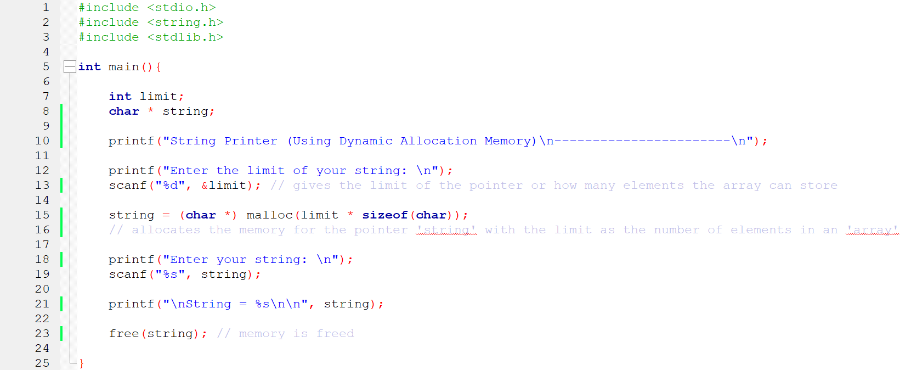

**Output:**

